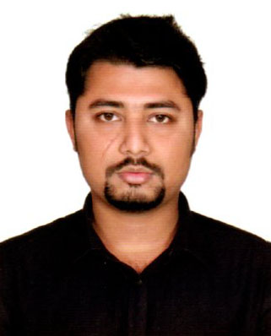
CURRICULUM VITAE
OF
MD. ABDULLA AL MAMUN

CONTACT ADDRESS:
Md. Abdulla Al Mamun
Char Hogla, Sonargaon, Narayanganj
Mobile No- 01869700968, 01685677801
E-mail- hasanmamun34ms@gmail.com
CAREER OBJECTIVES:
I can work hard and I have strong self-confidence. I would like to become a employee in your company .It is my passion. I think I must be able to utilize the best of my learning, experiences, understandings and significant contribution as a employee. I want to utilize my capabilities to work and organize the time effectively to maximize the output with faithful manner.
EMPLOYMENT HISTORY:
Total Year of Experience : 0.6 Year(s)
- Teacher ( January 20, 2019 - July 20, 2019)
Ministry of Primary and Mass Education.
Company Location : Government of the People`s Republic of Bangladesh. Ministry of Primary and Mass Education.
Department: Bureau of Informal Education.
Duties/Responsibilities:
Receive training and Teaching.
EDUCATIONAL QUALIFICATIONS:
Name of Examination/Degree | Board/University | Group/discipline |  | Year of passing | GPA
S S C | Dhaka | Science |  | 2010 | 3.50
H S C | Dhaka | Business Studies | 2013 |  | 3.10
BBA (Honours) | Dhaka | Marketing | 2017 |  | 2.99

INTERNSHIP:
Now I am studying Masters.
COMPUTER LITERACY:
Microsoft Office Word, Office Excel, C-Programming, E-mail and Internet Browsing etc.
LANGUAGE PROFICIENCY:
Language | Spoken Only | Written Only | Listening
Bangla | Excellent | Excellent | Excellent
English | Phonic sound | Good | Good

TRAINING SUMMARY
No | Training Title | Topic | Institute | Country | Location | Year | Duration
1 | Teacher | Health, General math, Importance Of Education, Social And Family Issues. | Ministry of Primary and Mass Education. | Bangladesh | Sonargaon, Narayanganj. | 2019 | 3 Months
2 | Basic Computer Application | Basic Computer | Srijon Institution Of Learning, Munshiganj. | Bangladesh | 32 Juboli Road, Munshiganj Sadar. | 2019 | 3 Months

PERSONAL INFORMATION:
Name : Md. Abdulla Al Mamun
Father’s Name : Md. Chan Badsha
Mother’s Name : Firoja Begum
Date of Birth : 13.08.1995
Hight : 5 fit 7 inch.
Nationality : Bangladeshi (By birth)
Religion : Islam.

PERMANENT ADDERSS: Md. Abdulla Al Mamun
Father : Md. Chan Badsha
Village : Char Hogla,
P.O : Kashemnagar
Post Code : 1500
P.S : Sonargaon
District : Narayanganj
PRESENT ADDRESS: Abdulla Al Mamun
Char Hogla, Sonargaon, Narayanganj
Mobile No- 01869700968
I declare that, to the best of my knowledge and belief this curriculum vita correctly describes my qualifications and myself as well.
Signature



…………………… Abdulla Al Mamun ……..………….

